TRAINING VISA (SUBCLASS 407)-STANDARD OPERATING PROCEDURE

Document Control
Document No. | SOP-TV-001
Version | 1.0
Department | Migration Services
Effective Date | ________________
Approved By | ________________

Purpose
This Standard Operating Procedure (SOP) establishes a consistent, efficient and compliant process for managing Training Visa (Subclass 407) applications from the initial enquiry through to the final visa outcome.
This SOP aims to:
- Standardize the Training Visa application process across the organization.
- Ensure compliance with Australian migration legislation and Department of Home Affairs requirements.
- Clearly define the responsibilities of Registered Migration Agents and Consultants.
- Deliver professional and efficient services to sponsors and visa applicants.
- Maintain accuracy, consistency and quality throughout the sponsorship, nomination and visa application process.
- Ensure all client records are securely maintained in accordance with the agency's Document Management Procedure.
- Promote continuous improvement and quality assurance in migration services.

- Scope this procedure applies to all Training Visa (Subclass 407) applications managed by Yale Migration.
The SOP covers:
- Initial client enquiry
- Sponsor eligibility assessment
- Applicant eligibility assessment
- Client engagement
- Sponsor consultation
- Occupational Training Program assessment
- Training Plan preparation
- Temporary Activities Sponsorship (TAS) assessment (where required)
- Nomination application
- Visa application
- Document collection and verification
- Sponsorship lodgment (where required)
- Nomination lodgment
- Visa lodgment
- Post-lodgment monitoring
- Section 56 Requests for Further Information
- Visa outcome management

Roles and Responsibilities

Registered Migration Agent
The Registered Migration Agent is responsible for ensuring compliance with Australian migration legislation throughout the sponsorship, nomination and visa application process.

Responsibilities
- Assess sponsor eligibility.
- Assess applicant eligibility.
- Determine whether the sponsor holds an approved Temporary Activities Sponsorship (TAS).
- Assess the nominated occupational training program.
- Prepare Service Agreements.
- Send sponsor and applicant document checklists.
- Prepare quotations.
- Review the Training Plan to ensure it satisfies Department requirements.
- Conduct consultations with both the sponsor and the applicant.
- Provide migration advice and identify potential migration risks.
- Review sponsorship, nomination and visa documentation.
- Conduct final quality assurance before lodgment.
- Lodge Sponsorship (if required), Nomination and Visa applications through ImmiAccount.
- Monitor application progress.
- Respond to Department requests, including Section 56 Requests.
- Provide post-decision advice to sponsors and applicants.

3.2 Consultant
The Consultant is responsible for coordinating communication, documentation and administrative support throughout the application process.

Responsibilities
- Respond to sponsor and applicant enquiries.
- Conduct the initial client screening.
- Collect preliminary information.
- Endorse eligible enquiries to the Registered Migration Agent.
- Register clients in the Client Management System.
- Generate Unique Client Codes.
- Create electronic client folders.
- Coordinate document collection.
- Review documents for completeness.
- Prepare supporting documentation.
- Follow up outstanding documents.
- Prepare invoices.
- Monitor application progress.
- Provide regular updates to sponsors and applicants.
- Upload documents into ImmiAccount following approval by the Registered Migration Agent.
- Update internal tracking systems.
- Maintain complete and accurate client records.

4. Tools and Systems
The following systems and resources are used throughout the Training Visa (Subclass 407) application process:

Systems
- ImmiAccount
- Client Management System (CMS)
- Client Engagement Log
- Secure Cloud Document Storage
- Microsoft Office / Google Workspace
- Email Management System

Standard Templates and Checklists
- Training Visa (Subclass 407) Checklist
- Sponsor Checklist
- Applicant Checklist
- Temporary Activities Sponsorship (TAS) Checklist
- Nomination Checklist
- Occupational Training Plan Template
- Occupational Training Program Checklist
- Training Schedule Template
- Service Agreement
- Client Quotation Template
- Client Consent Form
- Visa Application Checklist

Reference Materials
- Department of Home Affairs Legislative Instruments
- Department of Home Affairs Policy Manual
- Temporary Activities Sponsorship (TAS) Guidelines
- Occupational Training Program Guidelines
- ANZSCO Occupation List
- Department of Home Affairs Forms and Approved Templates
- Yale Migration Document Management Procedure
- Internal Quality Assurance Checklist
- Internal Training Visa Reference Guide
- Immiccount
- Client Management System
- Client Engagement Log
- Secure Cloud Document Storage
- Employer Checklist
- Employee Checklist
- Standard Business Sponsorship Checklist
- Labor Market Testing Checklist
- Nomination Checklist
- Visa Application Checklist
- Microsoft Office / Google Workspace
- Department of Home Affairs Legislative Instruments
- Skills in Demand Occupation List Reference
- CSIT Salary Reference Guide

5. Document Management

Every client must be registered in the Client Engagement Log to generate a Unique Client Code

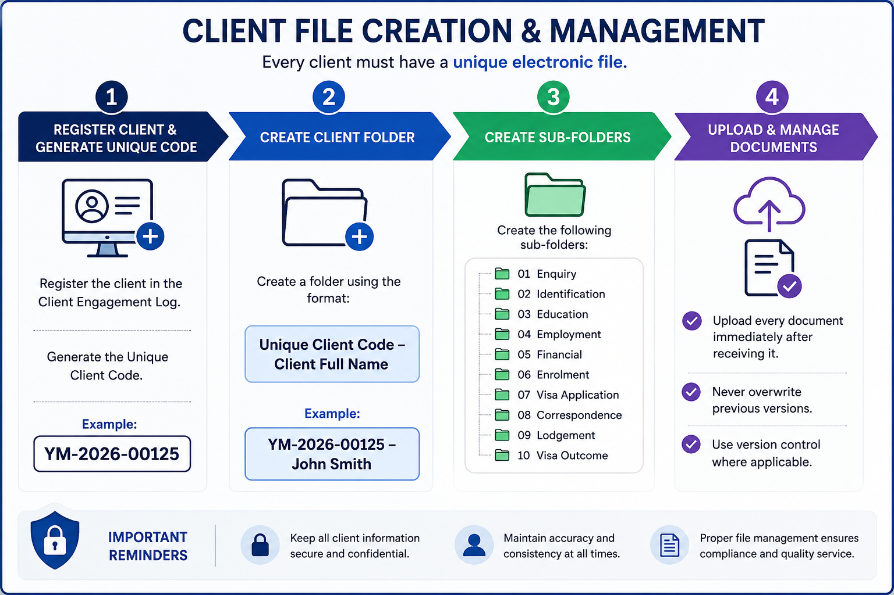

Step | Process | Procedure
1 | Register Client | Register the client in the Client Engagement Log and generate a Unique Client Code.  Example: YM-2026-00125
2 | Create Client Folder | Create a client folder using the following naming convention:  Unique Client Code – Client Full Name  Example: YM-2026-00125 – John Smith
3 | Create Sub-Folders | Create the following folders within the client's main folder:  01. Enquiry  02. Identification  03. Education  04. Employment  05. Financial  06. Enrolment  07. Visa Application  08. Correspondence  09. Lodgment  10. Visa Outcome
4 | Upload & Maintain Documents | Upload all client documents immediately upon receipt.  • Do not overwrite previous versions.  • Apply version control where necessary.  • Ensure all documents are saved in the correct sub-folder.

6. Training Visa (Subclass 407) Application Procedure

Step | Process | Responsible | Required Action
1 | Receive Enquiry | Consultant | Respond to enquiries from the sponsor or applicant via phone, email, social media or walk-in. Obtain preliminary information regarding the proposed training program and applicant.
2 | Initial Assessment | Consultant | Request the completed enquiry form, applicant's resume/CV, passport, current visa (if applicable), educational qualifications, employment history and sponsor information.
3 | Eligibility Assessment | Registered Migration Agent | Assess the eligibility of both the sponsor and the applicant. Determine whether the proposed occupational training meets the requirements of the Training Visa (Subclass 407).
4 | Sponsor & Applicant Consultation | Registered Migration Agent | Conduct a consultation explaining sponsorship requirements, occupational training categories, visa requirements, processing times, government fees, professional fees, visa conditions and obligations.
5 | Client Engagement | Consultant | Register the sponsor and applicant in the Client Engagement Log, generate Unique Client Codes, create electronic client folders, and send the quotation, Service Agreement and document checklists.
6 | Service Agreement & Initial Payment | Registered Migration Agent | Obtain the signed Service Agreement and confirm receipt of the engagement fee before commencing the application.
7 | Document Collection | Consultant | Collect all required sponsor and applicant documents in accordance with the agency's document checklists.
8 | Document Verification & Storage | Consultant | Review all documents for completeness and upload them into the client's electronic folder in accordance with the Document Management Procedure.
9 | Temporary Activities Sponsorship (TAS) Assessment | Registered Migration Agent | Determine whether the sponsor holds an approved Temporary Activities Sponsorship (TAS). If not, assess eligibility and prepare the sponsorship application.
10 | Occupational Training Program Assessment | Registered Migration Agent | Assess whether the proposed occupational training program satisfies the legislative requirements for the selected training category.
11 | Training Plan Preparation | Registered Migration Agent | Prepare the Occupational Training Plan, ensuring the objectives, structured workplace training, supervision arrangements and expected outcomes comply with Department requirements.
12 | Temporary Activities Sponsorship (TAS) Application** (if required) | Registered Migration Agent | Prepare and lodge the Temporary Activities Sponsorship application through ImmiAccount.
13 | Nomination Application Preparation | Registered Migration Agent | Prepare the Nomination application, ensuring all sponsor documents, Training Plan and supporting evidence are complete and compliant.
14 | Nomination Review & Lodgment | Registered Migration Agent | Conduct a final review and lodge the Nomination application through ImmiAccount.
15 | Visa Application Preparation | Consultant | Prepare the Training Visa (Subclass 407) application, upload supporting documents and complete the ImmiAccount draft.
16 | Client Review & Approval | Consultant | Send the completed visa application draft to the applicant for review and obtain written confirmation that all information is accurate before lodgment.
17 | Final Review & Visa Lodgment | Registered Migration Agent | Perform the final quality assurance review and lodge the visa application through ImmiAccount.
18 | Update Internal Records | Consultant | Update the Lodgment Register with the Sponsorship (if applicable), Nomination and Visa Transaction Reference Numbers (TRNs), lodgment dates and Bridging Visa details (if applicable).
19 | Post-Lodgement Communication | Consultant | Forward the visa lodgment acknowledgement, Bridging Visa Grant (if applicable), HAP ID, health examination instructions and any other relevant post-lodgment information to the sponsor and applicant.
20 | Application Monitoring | Consultant / Registered Migration Agent | Monitor the Sponsorship, Nomination and Visa applications through ImmiAccount. Respond promptly to Department requests, including Section 56 Requests for Further Information, and keep the sponsor and applicant updated throughout the process.
21 | Visa Outcome | Registered Migration Agent / Consultant | Notify the sponsor and applicant of the visa outcome. For granted applications, explain the visa conditions, training obligations and next steps. For refused applications, explain the decision and discuss available options where appropriate.
22 | File Closure | Consultant | Save all final correspondence, update the Client Engagement Log and Lodgment Register, and archive the sponsor and applicant files in accordance with the agency's Document Management Procedure.

Internal Quality Control Points
Before lodging any application, ensure the following:
- Sponsor eligibility confirmed.
- Temporary Activities Sponsorship (TAS) status verified or application prepared (if required).
- Occupational Training Program meets Subclass 407 requirements.
- Training Plan is complete and compliant.
- Sponsor documents verified.
- Applicant documents verified.
- Qualifications and employment history reviewed.
- Nomination application reviewed and approved.
- Visa application reviewed by the Registered Migration Agent.
- Client approval obtained.
- Government and professional fees confirmed.
- All supporting documents uploaded to ImmiAccount.
- Internal records updated.

7. Quality Control Checklist
The Registered Migration Agent must complete the following quality assurance checks before lodging any Training Visa (Subclass 407) application. No application is to be lodged until all applicable items have been reviewed and confirmed.
Quality Check | Completed (✓)
Sponsor identity has been verified, and the organization is eligible to sponsor a Training Visa (Subclass 407) applicant. | ☐
Temporary Activities Sponsorship (TAS) status has been verified, or a new sponsorship application has been prepared (if required). | ☐
The proposed Occupational Training Program meets the legislative requirements for the nominated training category. | ☐
Occupational Training Plan has been reviewed and approved by the Registered Migration Agent. | ☐
The training program clearly demonstrates structured workplace-based training and learning outcomes. | ☐
The training objectives are relevant to the applicant's current occupation, field of study or professional development. | ☐
Sponsor declarations and supporting documents have been reviewed and verified. | ☐
Applicant identity has been verified using a valid passport or government-issued identification. | ☐
Passport is valid for the intended visa application period. | ☐
Applicant meets the eligibility requirements for the Training Visa (Subclass 407). | ☐
Educational qualifications, employment history and supporting evidence have been reviewed and verified. | ☐
English language requirement has been met, and valid evidence has been provided (where applicable). | ☐
Overseas Visitor Health Cover (OVHC) or other appropriate health insurance has been arranged for the required visa period. | ☐
Police Clearance Certificates have been obtained where required. | ☐
All supporting documents have been reviewed for completeness, accuracy and consistency. | ☐
Sponsor and applicant information is consistent across all forms, declarations and supporting documents. | ☐
All required forms, declarations and consent documents have been completed and signed. | ☐
Sponsor and applicant have reviewed and approved the final application before lodgment. | ☐
Government fees, professional fees and all applicable third-party costs have been confirmed with the client. | ☐
All supporting documents have been correctly named, organized and saved in accordance with the Document Management Procedure. | ☐
Registered Migration Agent has completed the final compliance review and approved the application for lodgment. | ☐
Sponsorship (if applicable), Nomination and Visa applications have been successfully lodged through ImmiAccount. | ☐
Transaction Reference Numbers (TRNs), lodgment confirmations and all post-lodgment records have been saved in the client file. | ☐

Important
- Any missing, inconsistent or incomplete information must be resolved before lodging the application.
- The Occupational Training Plan must clearly demonstrate structured workplace-based training that meets the requirements of the selected training category.
- The Registered Migration Agent must verify that the sponsor satisfies all sponsorship obligations and that the proposed training program complies with current Department of Home Affairs policy.
- Any Request for Further Information (Section 56) issued by the Department of Home Affairs must be responded to before the specified deadline.
- The Registered Migration Agent is responsible for ensuring that the Sponsorship (if applicable), Nomination and Visa applications comply with current Australian migration legislation, Department of Home Affairs policy and professional obligations before lodgment.

8. Compliance and Disclosure
Yale Migration is committed to maintaining the highest standards of professionalism, ethical conduct and compliance with Australian migration legislation.
All staff involved in Graduate Visa applications must comply with the following requirements:

Legislative Compliance
- Comply with all applicable Australian migration legislation, regulations and policy requirements.
- Follow all requirements of the Department of Home Affairs when preparing and lodging visa applications.
- Ensure that all information provided in a visa application is accurate, truthful and supported by appropriate evidence.

Professional Responsibilities
- Only a Registered Migration Agent may provide migration advice or make legal representations regarding visa matters.
- Consultants and administrative staff must not provide migration advice unless authorised to do so.
- Any complex migration issues must be referred to the Registered Migration Agent.

Client Confidentiality
- Protect all client information in accordance with Australian privacy requirements and the agency's privacy policy.
- Client information must only be accessed by authorized staff for legitimate business purposes.
- Client documents must be stored securely within the agency's approved document management system.

Accuracy and Record Management
- Maintain complete, accurate and up-to-date client records always.
- Record all client communications, advice provided, and documents received or submitted.
- Ensure all electronic files follow the agency's document naming and filing procedures.

Fee Disclosure
Before commencing any work, the client must receive clear written information regarding:
- Professional service fees.
- Government Visa Application Charges (VAC).

Client Acknowledgement
Before visa lodgment, the client must acknowledge that:
- All information provided is true, complete and accurate.
- They have reviewed and approved the final visa application.
- They understand their obligations as a Student Visa holder.
- They understand that providing false or misleading information may result in visa refusal or cancellation.

Visa Outcome Disclaimer
Yale Migration will prepare and manage every application with due skill, care and diligence. However, the approval or refusal of any visa application is solely at the discretion of the Department of Home Affairs.
Neither Yale Migration nor the Registered Migration Agent can guarantee the grant of a visa, as each application is assessed on its individual merits and in accordance with Australian migration legislation and policy.

